The 10-Step Homepage Template

COMPANY: [enter company name here]
URL: [enter URL here]
Last Updated: [enter date of last update]

TARGET MARKET(S):
- Persona/Avatar #1
- Persona/Avatar #2
- Persona/Avatar #3

PRIMARY CTA: [i.e. register for a demo, take a trial, purchase a product, etc.]
SECONDARY CTA: [watch demo video, learn more, log in, etc.]

Lifecycle:
- Problem Aware - Aware of their problem, but not the solution
- Solution Aware - Aware that solutions are available, but not your specific product/service
- Product Aware - Aware of products/services like yours, but need a good reason to select your specific solution over all the others
- Actively Engaged - Fully aware of your brand, and just need a reason to engage at a new or different level

CORE MESSAGES:
- [Statement of Value]
- [List Jobs To Be Done]
- [Write out any relevant metaphors]
- [Include customer quotes and comments]
- [etc.]

[LOGO] Features About Us Log In [PRIMARY CTA]

[START BACKGROUND IMAGE - INSERT LINK TO RECOMMENDED IMAGE HERE]

NOTE: Image should show the customer as the hero in the “After” state

Your Attention-Getting Headline Should Go Here

An Optional Sub-Headline Should Go Here

ghost button → [Secondary CTA] [Primary CTA] ← contrasting button

[END BACKGROUND IMAGE]

[START TRUST BAR]

[LOGO] [LOGO] [LOGO] [LOGO] [LOGO]

[END TRUST BAR]

[START CONTRASTING BACKGROUND]

[OPTIONAL EXPLAINER VIDEO HERE]

[PLAY]

[END CONTRASTING BACKGROUND]

[START WHITE BACKGROUND]

How It Works [or what it does]
[Sub-Headline That Explains the End Result]

STEP 1: [insert step name]
[include a brief, 1 - 2 sentence description, here]

STEP 2: [insert step name]
[include a brief, 1 - 2 sentence description, here]

STEP 3: [insert step name]
[include a brief, 1 - 2 sentence description, here]

[repeat steps as needed…]

NOTE: The text portion of this section can be shorter if it is accompanied by an explainer video.

EXAMPLE FROM UNBOUNCE HOMEPAGE www.unbounce.com

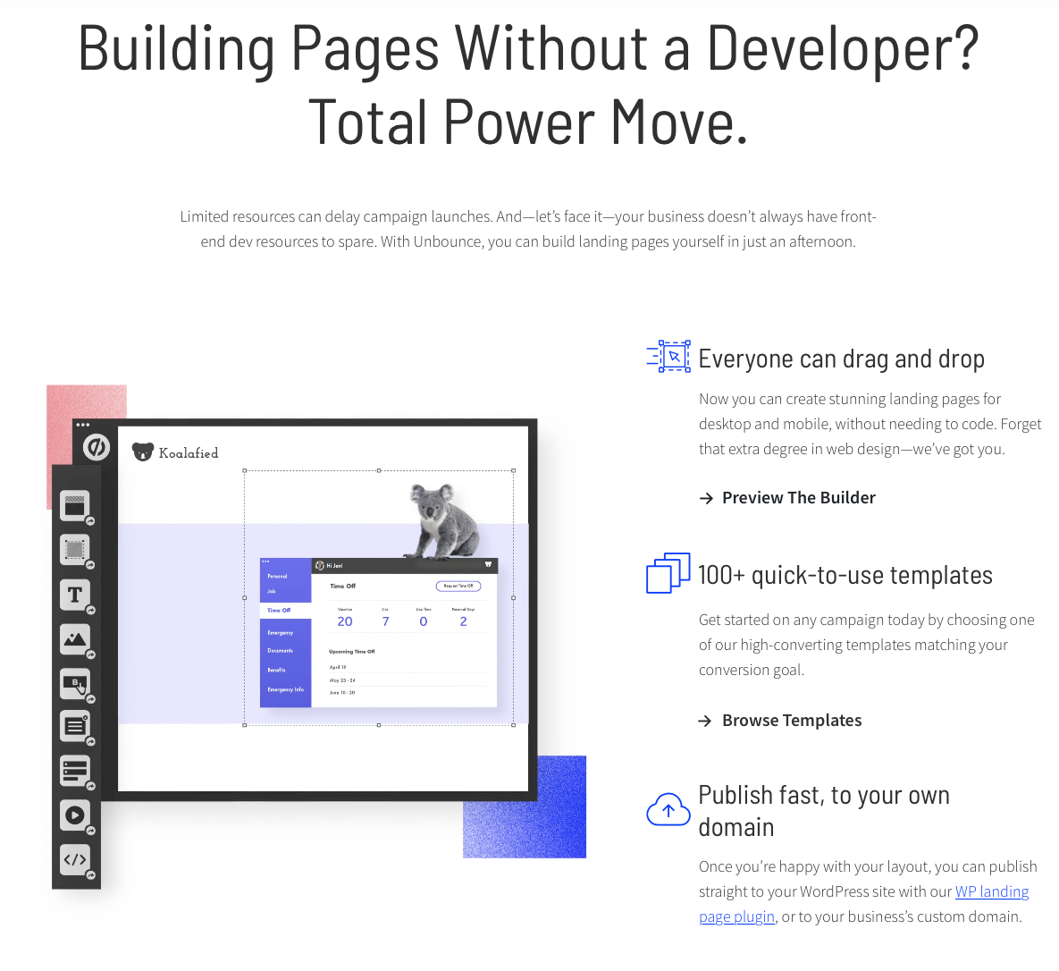

[END WHITE BACKGROUND]

[START BACKGROUND IMAGE / CONTRASTING BACKGROUND]

Who It’s For

[Break down each of the main avatars who would be interested in your product or service, and a specific use-case that would resonate with each of them.]

EXAMPLE FROM UNBOUNCE

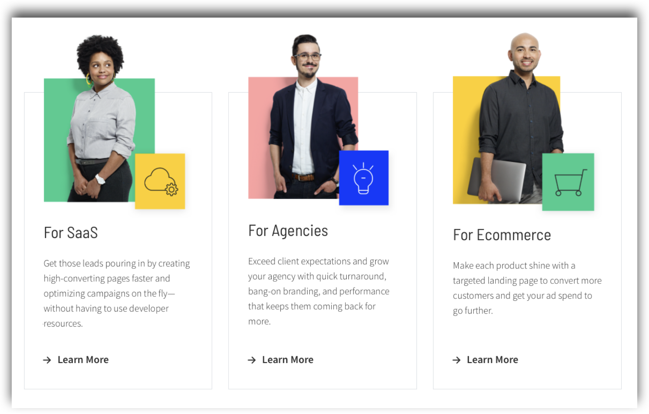

[RECOMMENDED: INSERT CUSTOMER TESTIMONIALS OR LINKS TO CUSTOMER STORIES THAT SUPPORT THE CLAIMS MADE IN THE “WHO IT’S FOR” SECTION. SEE “WHAT OUR CLIENTS SAY” AT THE BOTTOM OF THIS PAGE AS AN EXAMPLE: www.unbounce.com]

[END BACKGROUND IMAGE / CONTRASTING BACKGROUND]

[START GRAY BACKGROUND]

[Action-Based CTA That Speaks
To The Desired “After”]

[Optional sub-headline with clarifying details (i.e. pricing)]

[PRIMARY CTA AS A BUTTON OR FORM]

Example:

Build a Better Marketing Team
With Channel D

Plans start as low as $500/user for x service...

[Request a Demo] [Get Started]

[END GRAY BACKGROUND]

[START FOOTER]

Footer should Include your copyright statement, physical address, contact information, Terms of Service, Privacy Policy, expanded navigation, links to flagship content/case studies, links to social properties, and any other important but miscellaneous information.

EXAMPLE: https://coschedule.com/

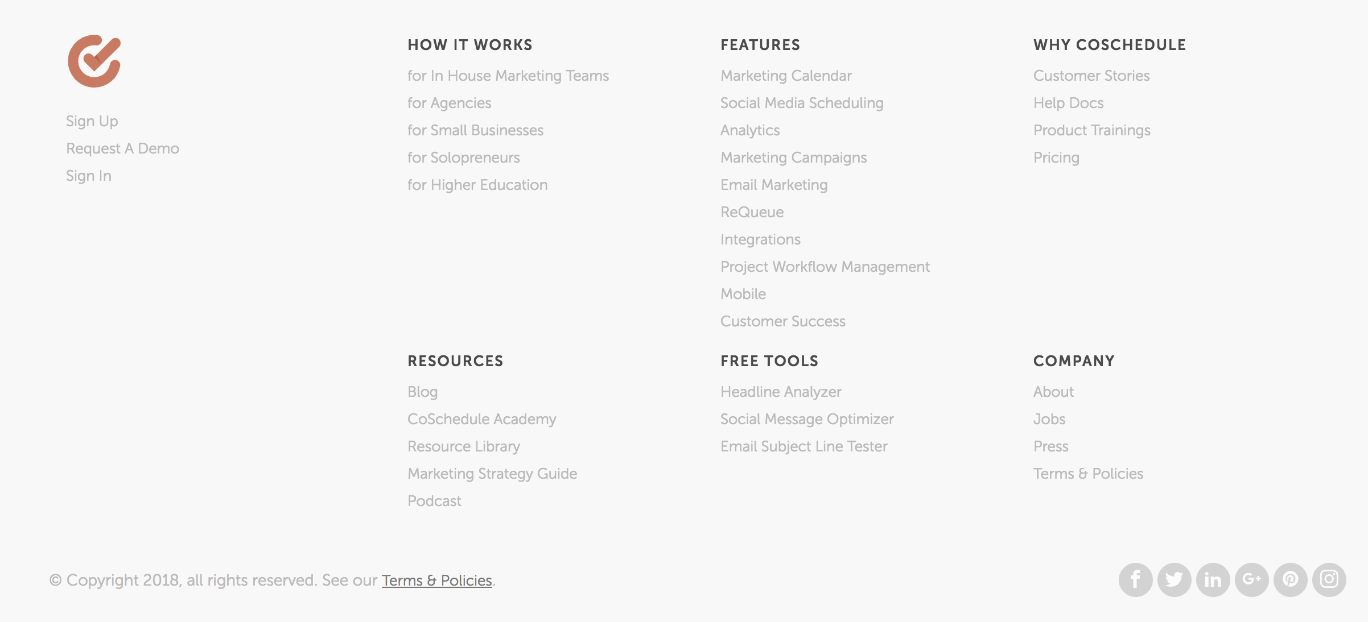

[END FOOTER]

